Anabaptism as Worldview
By Steven Brubaker
Course Workbook
____________________________________________________________________________________________________________________
What do Anabaptists value?
This eight-session series explores the forces that shape our worldview. In that context, we consider five beliefs and values emphasized by Anabaptists.

Session 1 Worldview – What is it? How do we get one?
Session 2 The Worldview of this Age.
Session 3 Setting the Table
Session 4 Anabaptist Emphasis #1
Session 5 Anabaptist Emphasis #2
Session 6 Anabaptist Emphasis #3
Session 7 Anabaptists Emphasis #4
Session 8 Anabaptist Emphasis #5

The divinely resourced organism for withstanding tsunamis of moral degradation is the church of Jesus Christ. A church anchored in 2000 years of faithful doctrine and practice, a church receiving with gratitude the wisdom that precedes it, a church building on the grace of the past is in the best position to not only withstand but turn back the shadow of evil and injustice – to prevail against the gates of hell.
Steven Brubaker

Session 1

Worldview: What is it?

Opening

Do not be conformed to this world,

but be transformed by the renewal of your mind…

Romans 12:2

Worldview Defined

The way I understand the world – like __________________

The way I define what is normal – like __________________

A Definition

The set of

What I

About

That shapes ________ I do and _______ I do it.


A Worldview Model

Everybody has his filter which he takes about with him, through which, from the indefinite mass of facts, he gathers in those suited to confirm his prejudices.... Rare, very rare are those who check their filter. Henri de Lubac.

Session 2

The Worldview of this Age


Tsunami!

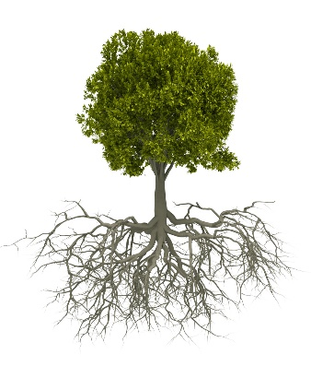

Do not be conformed to the _____________ of this age.

Do not let your ____________ and ______________

be pressed on you by the dominant culture.

Where do we get the power, the strength to resist, to overcome this overwhelming tsunami?

the God of our Lord Jesus Christ, the Father of glory
Ephesians 1: 15-22

the exceeding greatness of His power toward us who believe

(Jesus is) far above all principality and power and might and dominion, and every name that is named, not only in this age but also in that which is to come.

(the Father) gave (Jesus) to be head over all things to the church, which is His body, the fullness of Him who fills all in all.

Unless our theologian has the inner fortitude of a desert saint, he has only one effective remedy against the threat of cognitive collapse in the face of these pressures: He must huddle together with like-minded fellow deviants and huddle very closely indeed. Only in a counter community of considerable strength does cognitive deviance have a chance to maintain itself.

Peter Berger.

Thesis #1 – Anabaptism is a ___________ community of considerable ____________ for withstanding the current tsunami of moral defilement.

Thesis #2 Anabaptism is a counter community of considerable strength for mobilizing a ____________ tsunami of Christ followers that fill the earth with the glory of God.

What do Anabaptists value?
Sessions 1 - 3
Worldview – What is it?
The Worldview of this Age
Setting the Table
Sessions 4-8
Five Words that Describe the
Anabaptist –Christian Worldview

Session 3

Setting the Table

Opening

Thesis #1 Anabaptism is a counter community of considerable _________ for withstanding the current tsunami of moral degradation.
___________ STRENGTH.

Thesis #2 Anabaptism is a counter community of considerable strength for mobilizing a ____________ tsunami of Christ followers that fill the earth with the glory of God.
____________ STRENGTH.

Relating Ideas

Beliefs and values often come in ________.

Example: But seek ye first the kingdom of God, and his righteousness; and all these things shall be added unto you. Matthew 6:25-33.

Wisdom and understanding involves relating these ideas appropriately.

Existing Models

The ____________________ Model

The ____________________ Model

The ____________________ Model

The ____________________ Model

The ____________________ Model

A problem with these models is the inability to show when one idea is

more basic, primary, or fundamental than the other.

1st and 2nd Things Model

The Problems that arise with 1st and 2nd Things

____________ – making second things first (lose them both)

____________ - making them the same thing (lose them both)

____________ - making second things optional – then unimportant – then problematic

Our task

Keep 1st Things ________

_______ 2nd Things

Put first things first and we get second things thrown in: put second things first and we lose both first and second things. C S Lewis.

Harold Bender. The Anabaptist Vision.

First and fundamental in the Anabaptist vision was the conception of the essence of Christianity as ______________. It was a concept which meant the transformation of the entire way of life of the individual believer and of society so that it should be fashioned after the teachings and example of Christ.

As a second major element in the Anabaptist vision, a new concept of the church was created by the central principle of __________ of life and applied Christianity. Voluntary church membership based upon true conversion and involving a commitment to holy __________ and discipleship was the absolutely essential heart of this concept.

The third great element in the Anabaptist vision was the ethic of ______ and nonresistance as applied to all human relationships. The Brethren understood this to mean complete abandonment of all warfare, strife, and violence, and of the taking of human life.

The ________ that God has surrounded us with is often transparent. We must deliberately become _________ detectors, sniffing out where God has blessed us. This is not living in denial of the wrongs or creating some false imaginary world, but actively looking for, naming, and saying thank you for God’s ________ in our lives.

Anabaptism is…

A heritage of faithfulness to God.

A heritage deeply formed by the good news of Jesus.

A heritage shaped by the Scriptures.

A heritage used of God to call many to himself.

But, also, a heritage with significant failures.

Session 4

Anabaptist Emphasis #1

Introduction

Then Jesus said to his disciples, "If anyone would come after me, he must deny himself and take up his cross and follow me.” Mt 16:24.

Why was adult baptism so significant for the early Anabaptists?
}

Following Christ is a

____________________________

…commitment to Jesus and His people.

____________________________

____________________________

____________________________

____________________________

Anabaptists Emphasize ________________

Devotion is deeply held love for and loyalty to ________.

And you shall love the Lord your God with all your heart and with all your soul and with all your mind and with all your strength. Mark 12:30

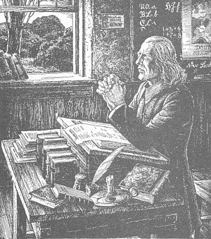
A Picture of Devotion

Christopher Dock

“his religion was not superficial and external, but essential - a devout and wholehearted following of Christ was his great concern.”

Practices

Adult _______________

___________ _______________

How can we cultivate passionate belief in our children and in each other rather than mere conformity to community expectations?

Proverbs 2:1. My son, if you accept my words and store up my commands within you, 2 turning your ear to wisdom and applying your heart to understanding, 3 and if you call out for insight and cry aloud for understanding, 4 and if you look for it as for silver and search for it as for hidden treasure, 5 then you will understand the fear of the LORD and find the knowledge of God.




Session 5

Anabaptist Emphasis #2

Question #1: Is the _________ given to aid the individual Christian in his maturity or is the __________ to participate in the maturing of the body of Christ?

Question #2: Is the most basic unit of life in the kingdom the _________ or the ____________?

Whether Catholic, evangelical, mainline, liberal or conservative, Christians see themselves as individuals first and communities second. James Sire.

Anabaptists emphasize ______________.

Anabaptists understand the focus of God’s work on the earth is the body of Christ – the ______.

And I tell you, you are Peter, and on this rock I will build my _________, and the gates of hell shall not prevail against it.

If you want to know what God is up to in the world look to the local ________.

The good news of Jesus Christ is not about me. Or you. The grand story of God at work in the world does not revolve around you or me. It revolves around Christ and the body of Christ – the _________. As we participate in His church, in the brotherhood, we enter and become part of that larger story, God’s story.

Followers of Christ find _________, ___________, and ________ in the church.

Costs: Anabaptists Understand that the Benefit of Brotherhood Comes at a Cost. This cost includes:

Staying engaged when everything in me wants to ______

Pushing through ______________ in the people around me

Pursuing the interests of people I don’t really ______

Admitting that I could be _________

Supporting the group when a ________ is made that I don’t agree with

Prioritizing all opportunities to be _______ the brotherhood

Spending a lot of ______ together – when I would rather be doing something else.

_______________ to a common creed, common values, common practices, common culture – not all of which I would choose

Bringing our best thinking, our best ideas, our greatest creativity to bear for the good of the __________ – not just our businesses or families

_____________ as an individual so I have something to benefit the group

Brotherhood involves a commitment to stay connected to the church - period.

G____________________

yieldedness, surrender, rest

Practices
 |  | 
______________ after the service | Congregational _____________ | _______  __________



If Brotherhood

is to remain an emphasis

among us, we must creatively,

imaginatively recommit to being

together.

Session 6


Anabaptist Emphasis #3

Is the Anabaptist emphasis on Christ any different from the rest of western Christianity?
Nachfolge Christi
___________ Christ
Anabaptism is _______-centered.

Therefore go out from their midst, and be separate from them, says the Lord, and touch no unclean thing; then I will welcome you.. 2Co 6:17

For the gate is narrow and the way is hard that leads to life, and those who find it are few. Mat 7:14

Anabaptists emphasize ________________.

Christ’s followers will be out of _____ with the dominant ________.
2nd Thing – Separated ______ __________
1st Thing – Separated ____ __________

In light of the record of contemporary Christianity, it seems vital to emphasize both the separated _________ and separated _______ nature of Christianity.

A church that looks and talks and sounds just like the world

has no reason to exist. Rob Dreher.

Not different for ___________ sake but different for _______ sake.

Why is it that when we Anabaptists have historically read the Bible we come to the conclusion that Christians are?
- not to fight in the military  - not to swear oaths,  - not to remarry while a spouse is still living,  - not to sue another person,  - to expect to suffer for their faith,  - to prioritize service to the poor and needy,  - to practice church discipline,  - to wear head coverings if a women,  - to reject jewelry,  - to wear modest/simple/non-conformed attire, | - to practice a simple/plain lifestyle,  - to practice an emphasis on community and the brotherhood,  - to avoiding positions of corporate or political power,  - to practice separation from media and many forms of entertainment,  - to understand that how a Christian lives their life is inseparable from their confession of faith,  - to focus on the separation of the kingdoms of this world from the Kingdom of God, etc.?

Perhaps a few Christian groups subscribe to some of the above list, but to my knowledge this package is rather unique to us Anabaptists. Dan Ziegler.

A Picture
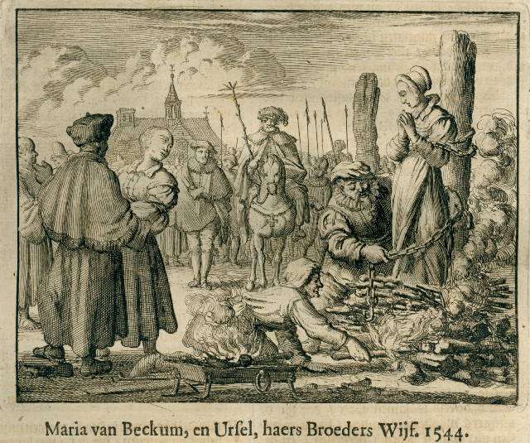 | He who would follow Christ in life,  Must scorn the world’s insult and strife,  And bear his cross each day.  For this alone leads to the throne  Christ is the only way.  Jorg Wagner. Ausbund.

Practices
# 1The ______ ________ | #2 Church ____________
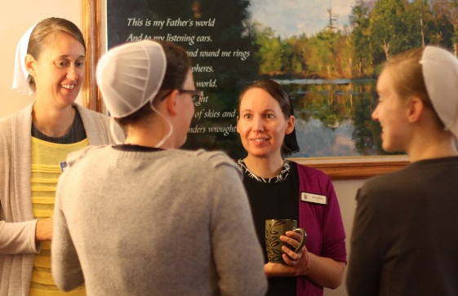 | The decline of church discipline is perhaps the most visible failure of the contemporary church. No longer concerned with maintaining purity of confession or lifestyle, the contemporary church sees itself as a voluntary association of autonomous members, with minimal moral accountability to God, much less to each other. Albert Mohler.  If (the church) no longer conceives of itself as a voluntary disciplined body of followers of Christ it will have lost its reason for existence. Winfield Fretz.

__________ Focused AND _________ Cultural

Session 7

Anabaptist Emphasis #4

How can we fight evil in the world?

What does Jesus want his followers to do about the problems (evil) in the world?

Anabaptists emphasize __________ ______

Dirk Willems  1569 | 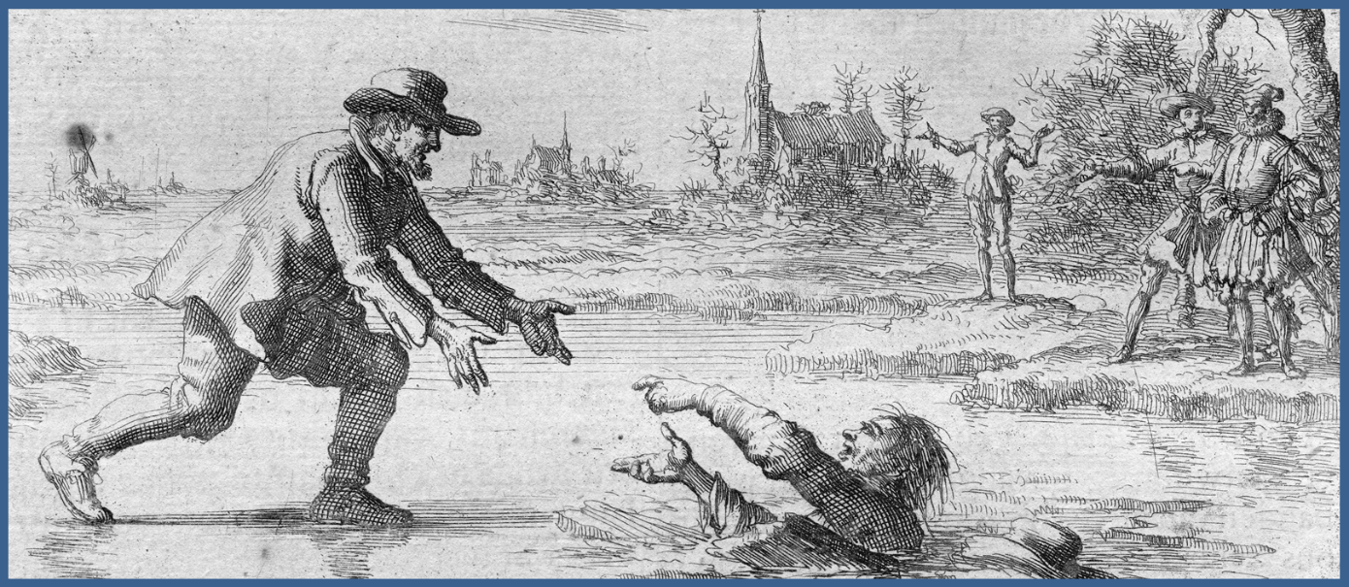

Two Components of Sacrificial Love
1 | What God is doing _____ us. | You shall love the Lord your God with all your heart and with all your soul and with all your mind.  Love your enemies… | God is making his followers into _______ – of God, brother, neighbor, and enemies
2 | How God wants to address evil __________ us. | The weapons we fight with are not the weapons of the world.  …overcome evil with good. | Christ-followers fight evil through sacrificial _____ & redemptively prophetic _______

Practices
____________ Service | Overcoming ______ with _____  Stories
1W  Hillcrest  Mountain View  Faith Mission Home  Choice Books  Olive Branch  Northern Youth Programs | 

Cautions

Turning nonresistance into __________________

Turning nonresistance into an idea about enemies _____ there rather than a lived reality _____ here.

Financial prosperity often corresponds to a loss of ________ for and ______________ to sacrificial love

The Two Most Quoted Scriptures by Early Anabaptists

___________ 28:19 - Make disciples of all nations

_________ 24:1 – The earth is the Lords.

Session 8

Anabaptist Emphasis #5

B _____________________

L _____________________

S _____________________

S _______________ ___________

D ____________________

Which is most fundamental?

Anabaptists Emphasize ______________

L_____________, B________________, D_______________

HWJL rather than WWJD

Sustained, daily, ordinary __________ _________ and ________ our love for God.

T E X T S | Everyone then who hears these words of mine and does them will be like a wise man who built his house on the rock. And the rain fell, and the floods came, and the winds blew and beat on that house, but it did not fall, because it had been founded on the rock. And everyone who hears these words of mine and does not do them will be like a foolish man who built his house on the sand. And the rain fell, and the floods came, and the winds blew and beat against that house, and it fell, and great was the fall of it. Jesus.  For whoever thinks he belongs to Christ must walk the way that Christ walked. Hans Denck  For true evangelical faith...cannot lay dormant; but manifests itself in all righteousness and works of love; it...clothes the naked; feeds the hungry; consoles the afflicted; shelters the miserable; aids and consoles all the oppressed; returns good for evil; serves those that injure it; prays for those that persecute it. Menno Simons.

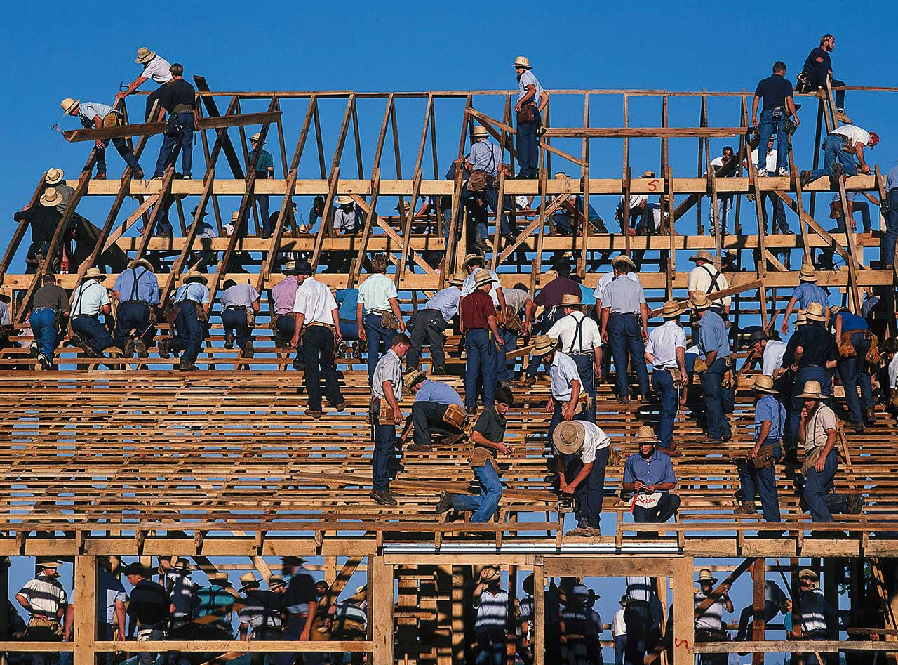
Christ Centered __________
Bible Centered _________

*********
A Hermeneutic of ___________________

Practices
Eating, Working, Playing  as ______________ | _________  Communion
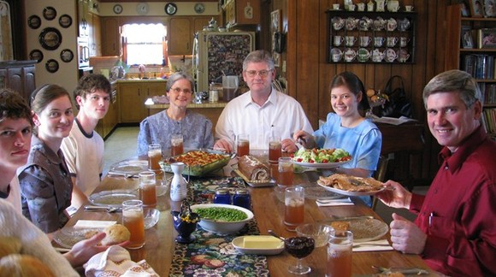 | 

Cautions

_____________ - following Jesus is reduced to certain behaviors that form a shell without life

______________ - overconfidence in man’s ability apart from Christ.

____________________ - the life of the mind is seen as a barrier to authentic Christianity.

Five Anabaptist Emphases

B___________________
Followers of Christ find identity, belonging, and purpose in the ________.

L __________________
Followers of Christ ______ each day in trusting obedience.

e
S __________________
Followers of Christ ___________ from the evil practices of the age.
S__________________ ____________
Followers of Christ are becoming lovers of others – even __________

e
D __________________
Followers of Christ are lovingly ___________ to God – heart, soul, mind, strength

*********************

Gratitude improves our _______________.

Gratitude opens us to more _____________.

